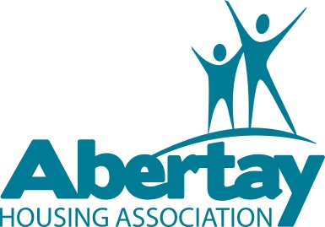
Notice to all Abertay tenants
It’s survey time!
We have included a satisfaction survey with your newsletter which you should be receiving shortly. Please find the time to complete this survey and return to us in the Freepost envelope provided.
Alternatively you can complete the survey online at:
https://www.surveymonkey.com/s/3QNDYRM
Why do we need this?
The Housing Scotland Act 2010 and the Scottish Social Housing Charter have placed an obligation on landlords to survey their tenants and service users regularly and submit the results to the Scottish Housing Regulator.
The survey will help us identify where we are meeting, exceeding or failing tenant and service user expectations. Being able to measure satisfaction will allow us to make important decisions on changes to the services we provide you. It’s not just about whether we are doing the right things but that we are also doing things right. So your feedback is important to us!
We intend to hold a prize draw from the surveys we receive so please remember to include your contact details. This is optional, you can remain anonymous if you wish, but please be aware we will not be able to include you in the prize draw. Prizes include vouchers for Tesco, Asda and Hydro electric .
Be assured that all of the information collected through the survey will be treated as strictly confidential and will only be used for the purposes of assisting the Scottish Housing Regulator in its role of monitoring and assessing landlords’ performance against the Charter.
Closing date for completion of the survey is 2nd August 2013. If you have not received your survey questionnaire with our newsletter please contact Customer Services on Tel No. 903545 and we will be happy to deliver one to your home.

