Notice to all Tenants
You are cordially invited to Abertay’s 17th Annual General Meeting
on Wednesday 18th September 2013 in Fintry Parish Church @ 6.30 pm

As in previous years, there will be a report from our Chairperson, along with the presentation of our Annual Accounts. All Shareholders will have the opportunity to vote and stand for committee and, as we are a tenant led organisation, we need more tenants on our Committee of Management. If you are interested in becoming a member, or would like to come along to one of our committee meetings as an observer, then please contact Chief Executive Ian Thomson.

Immediately following this year’s AGM we will be holding a Special General Meeting to discuss proposed changes to our Rules.

Thereafter we will be entertained by Alan Duncan from The Grey Lodge Settlement Centre in Dundee who will talk to us about Mary Lily Walker. Mary Lily Walker is one of Dundee’s forgotten heroines and 2013 marks one hundred years since her death. She founded Scotland’s first Infant Health Service as well as the first Nursing Mothers’ Restaurant and the community centre that she established, Grey Lodge Settlement, still serves families living in the city. In addition, her name has been linked with Dundee’s housing centre: the Lily Walker Centre but despite this, her commitment to Dundee, and the many achievements that came from it, has been forgotten over time. The anniversary of her death marks the perfect time to renew her memory.

The evening will finish with our renowned buffet, very generously made for us by the Ladies of Fintry Parish Church.

All in all it we look forward to a very enjoyable evening and we do hope to see you there!

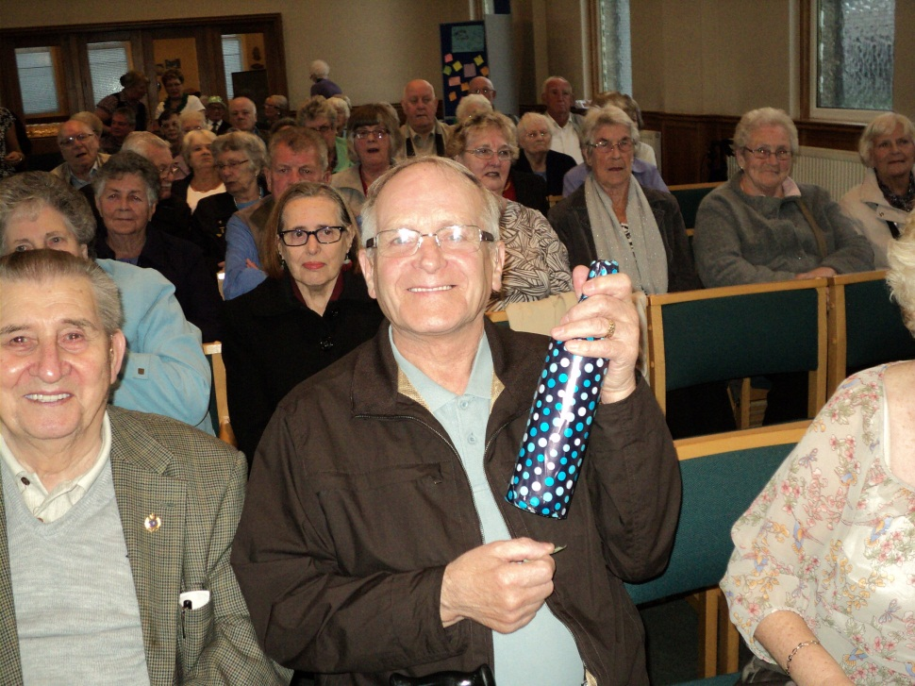
Picture from last year’s AGM
AGM be

