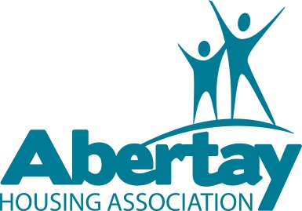
Annual Report
Feedback Survey

We really value your opinion, as this helps us improve the service you receive.
We would appreciate if you could take a couple of minutes to fill in this survey. It can be emailed back to our Tenant Participation Officer or printed and handed in to the Abertay Housing office at 147 Fintry Drive. You will be entered into a £25 prize draw if you return your completed survey before Tuesday 15th December 2015.

Annual Report 2014 / 15 feedback form

How happy were you with the following (please tick)
 | Very happy | Fairly happy | Neither | Fairly unhappy | Very unhappy
The front cover of the new report?
The style and layout of the new report?
The content of the new report?
The clarity of the information given?
The performance of Abertay for the year?

Overall, how do you think the new style 2014 / 15 report compares to the old style 2013 / 14 report? (Please tick)

Much better | Slightly better | Much the same | Slightly worse | Much worse
Is there any other information that you would like to see in the Annual Report next year?

Any other comments or feedback?

Name: ________________________________________________________________

Address: ______________________________________________________________

E-mail address: _________________________________________________________

Telephone no: __________________________________________________

Many thanks, Abertay Housing Association

